**PART A: Create a folder on the desktop**

1. Right-click with your mouse anywhere on the desktop, as long as the area is blank.
2. From the menu that appears, select on **New**, it opens another pop-out menu. Then, click on **Folder**.

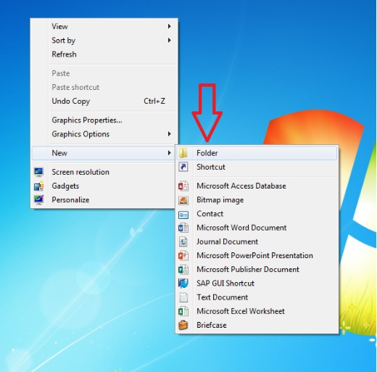

1. You'll get a new folder on the desktop. The cursor will be automatically placed inside the folder name, so you can type the folder name then press **Enter**. For example, if your name is **Pandelela Rinong** from group **FL3**, thus

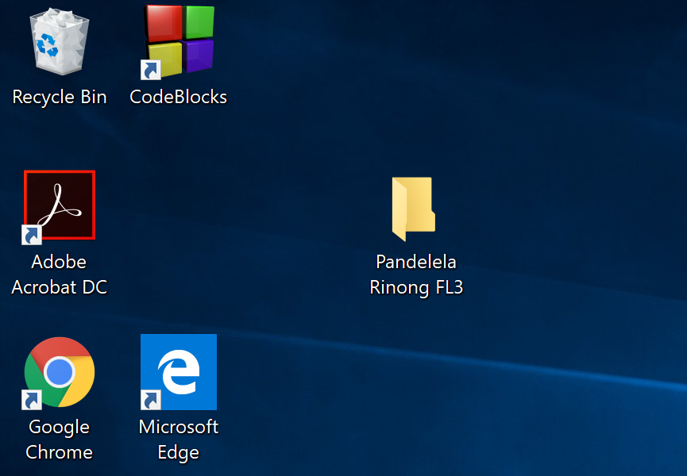

1. If you don't type in a name, your folder will be saved as "New Folder". If you want to change the folder name, right-click the folder, and choose **Rename**. Type the new name and press **Enter**.

**PART B: Introduction to Code::Blocks and setting up a file**

1. Begin the exercise by clicking the **START** button from **Window Taskbar** and select **Programs**. Click the **Code::Blocks** program. This will bring up the template window below.

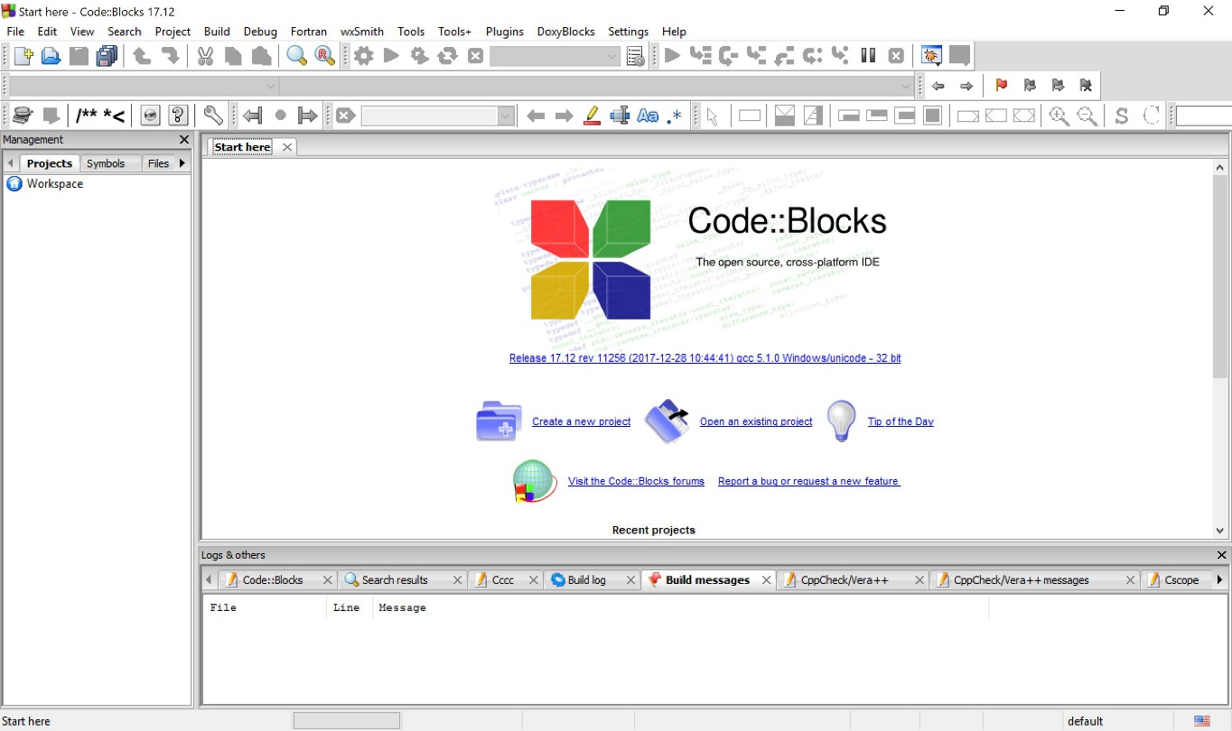

1. Click on the **Create a new project**. (Refer the **red circle** at the above figure).
2. This will bring up the **New from template** window. Select **Files** and **C/C++ Source**. After selecting **C/C++ source,** click on the **Go** button.

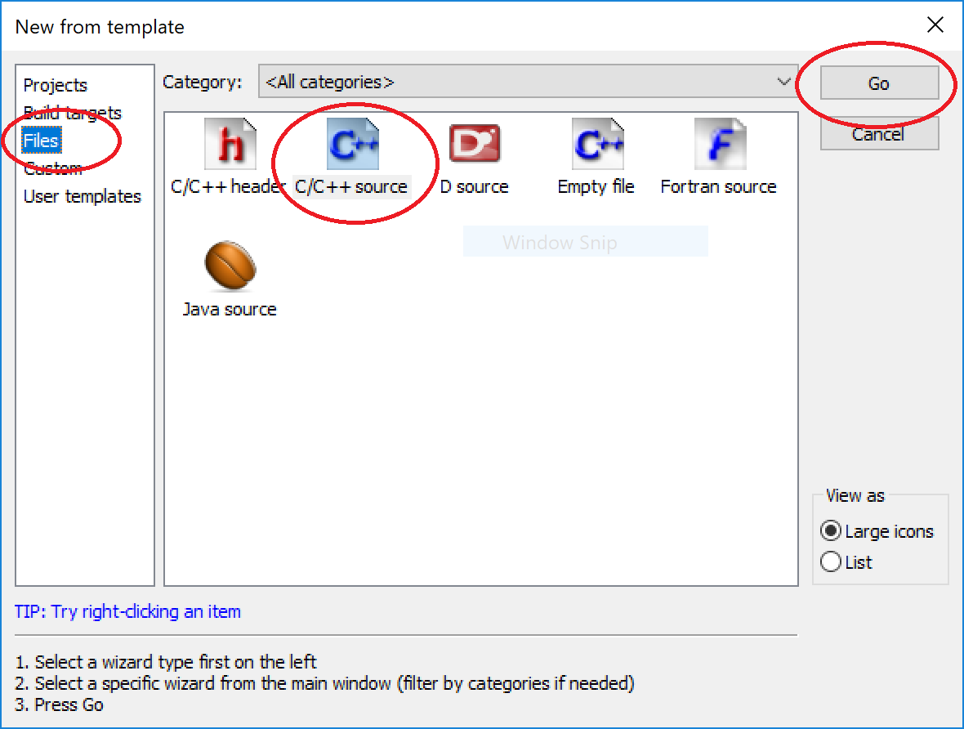

1. Press **Next** to go to the next step.
2. The next window allows you to choose the language that you will use. Select the language as **C**, then press **Next.**

|  |  |
| --- | --- |
|  |  |

1. Click on the square button .
2. Next, click on **Desktop** and choose the folder which you’ve created. Then, press **Open**.

|  |  |
| --- | --- |
|  |  |

1. Give a name to the file. Here it is called **T1Q1** to represent question no 1 in tutorial 1. The file need to be of Save as type **C files (*.c,*.C)**. Press **Save** to save the file.
2. Finally, click on **Finish**.
3. The Sources now has **T1Q1.c** as a source file.

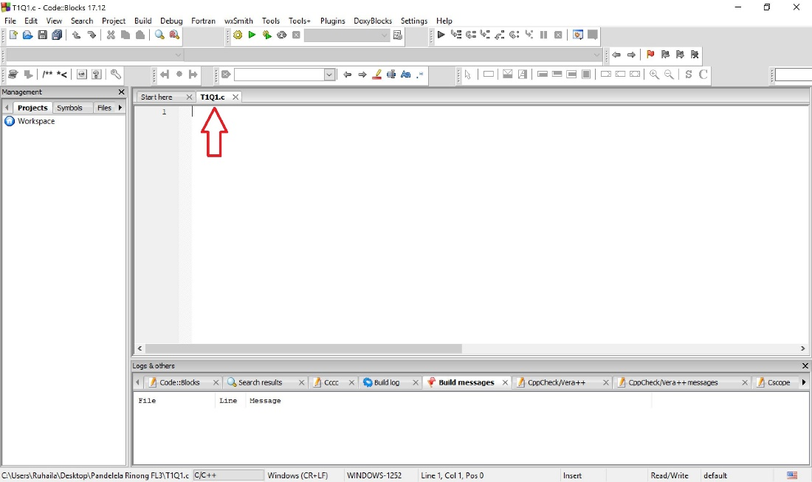

1. Copy the C source code below.

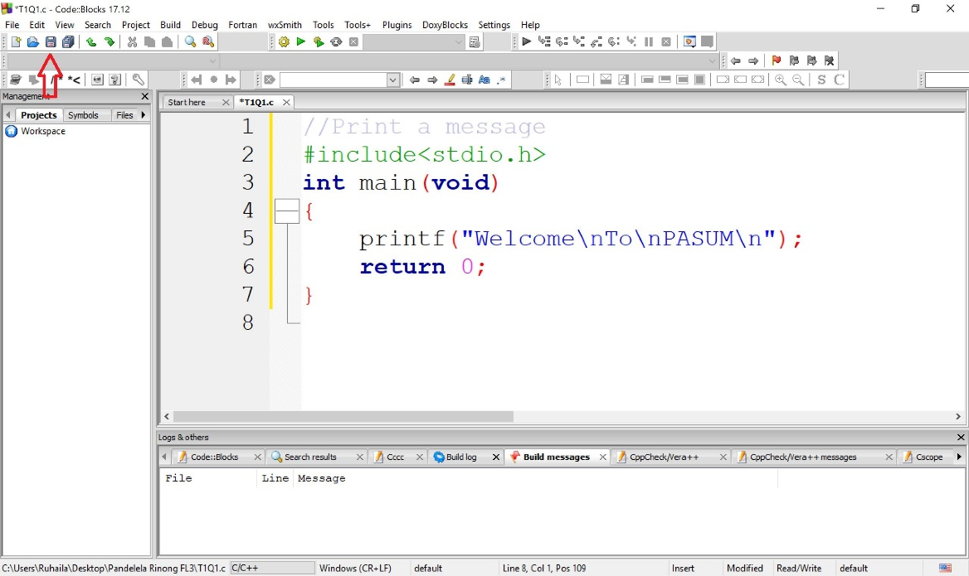

1. When finished, press the save icon .

**PART C: Compiling the program.**

1. Compile your file from the **Build** pull-down menu by clicking on **Build and run** (F9). To compile a file means to take the instructions that you have written and translate it into machine code for the computer to understand.

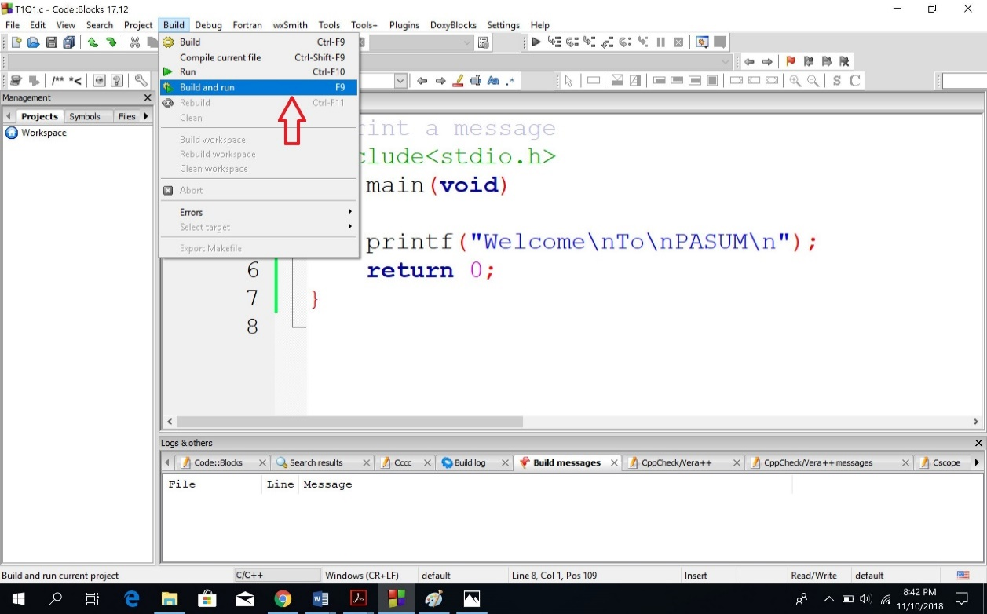

1. This is the output from the **Question 1** program. Pressing any key will exit the program.

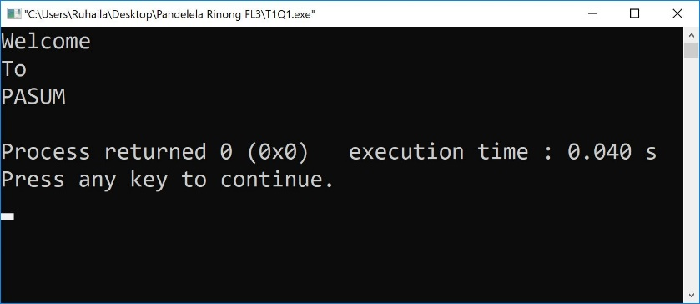

**PART D: Creating Another New File**

1. To practise, create another New file (you have to repeat PART B, steps 1 – 9). Name the file as **T1Q2**.
2. Copy the C source code below.

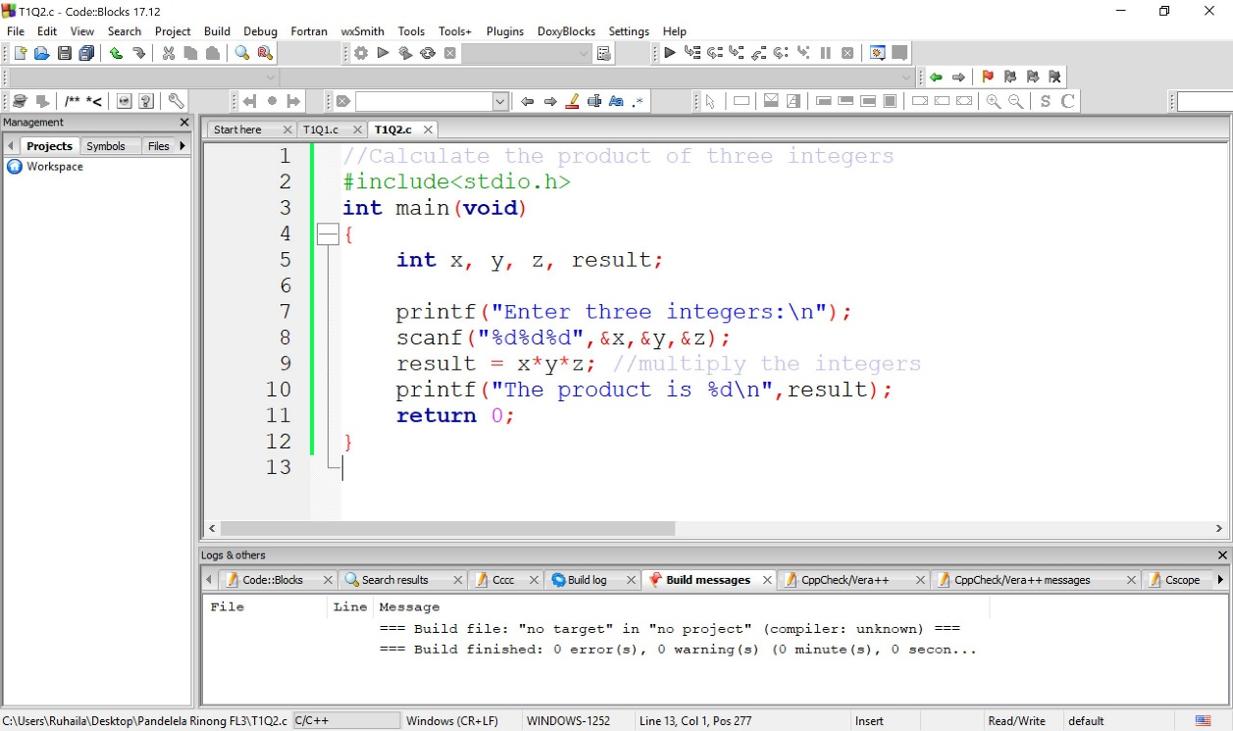

1. You may **save** the file, then **Build and run** the program.
2. When you were done, the output should be

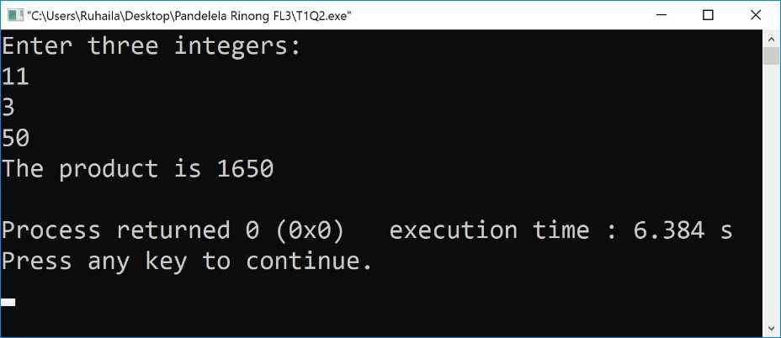

**Additional Exercises**

1. Write a C program that prompt the user to enter 5 floating point numbers and display the average of the numbers.
2. Write a C program to get the sum of two number, the result of the subtraction, the result of division and multiplication result when two numbers are read as input value from user.
3. Write a C program to Find Hexadecimal Integer Value of an Integer
4. Write a C program to find the volume of Cylinder and Pyramid (variable value input from user).
5. Write a C program that taking input as the 'age' of the user. After taking input, checking the age of the user. If the age of the user is greater than or equal to 18, then the output will show "eligible for voting" message otherwise, the output will show "not eligible for voting" message. (use **conditional operator**)